Modbus setting in COM2 for WECON PLC

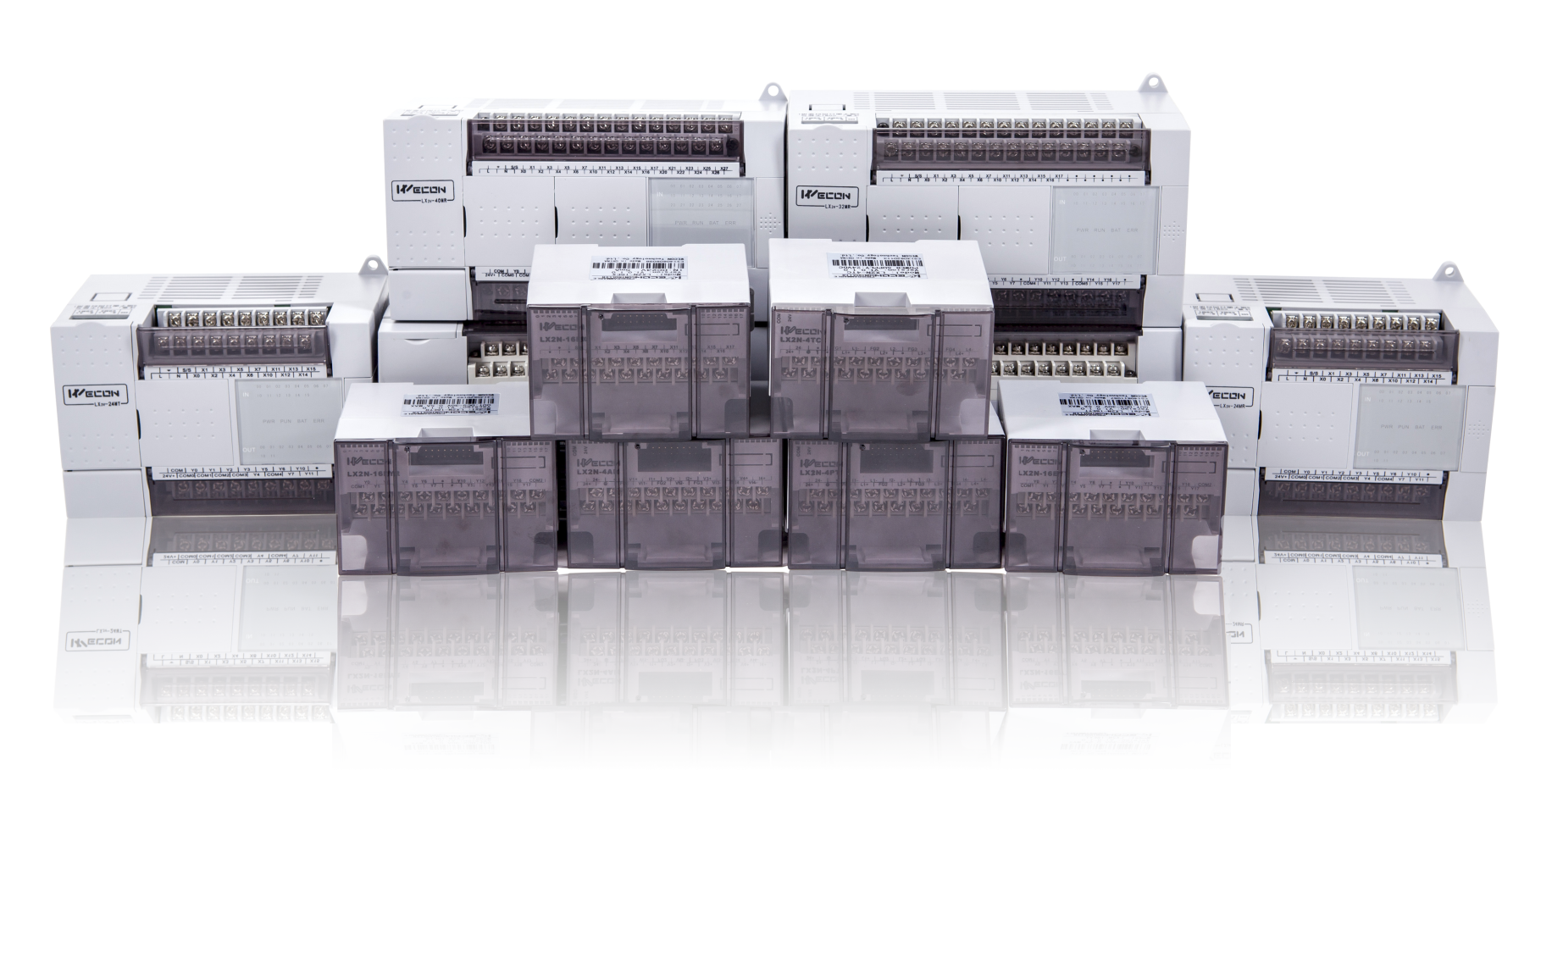
WECON Technology Co., Ltd.

Website: http://www.we-con.com.cn/en
Technical Support: liux@we-con.com.cn
Skype: fcwkkj
Phone: 86-591-87868869
Forums: http://wecon.freeforums.net/

Ⅰ. Protocol Setting (D8126)
Protocol | Description | Value of D8126
WECON PLC Protocol | Using WECON PLC Protocol | 01H
MODBUS RTU Master | PLC is slave device | 02H
MODBUS ASCII Master | PLC is slave device | 03H
MODBUS RTU Slave | PLC is master device | 20H
MODBUS ASCII Slave | PLC is master device | 30H

Ⅱ. Communication Format (D8120)
Item | parameter | Bit value of D8120
Item | parameter | b7 | b6 | b5 | b4 | b3 | b2 | b1 | b0
Baud rate  (Bps) | 115200 | 1 | 1 | 0 | 0 | - | - | - | -
Baud rate  (Bps) | 57600 | 1 | 0 | 1 | 1 | - | - | - | -
Baud rate  (Bps) | 38400 | 1 | 0 | 1 | 0 | - | - | - | -
Baud rate  (Bps) | 19200 | 1 | 0 | 0 | 1 | - | - | - | -
Baud rate  (Bps) | 9600 | 1 | 0 | 0 | 0 | - | - | - | -
Baud rate  (Bps) | 4800 | 0 | 1 | 1 | 1 | - | - | - | -
Stop bit | 1 bit | - | - | - | - | 0 | - | - | -
Stop bit | 2 bit | - | - | - | - | 1 | - | - | -
Parity | None | - | - | - | - | - | 0 | 0 | -
Parity | Odd | - | - | - | - | - | 0 | 1 | -
Parity | Even | - | - | - | - | - | 1 | 1 | -
Data bit | 7 bit | - | - | - | - | - | - | - | 0
Data bit | 8 bit | - | - | - | - | - | - | - | 1
Example: the communication format is 9600.1.8.None, b7b6b5b4=1000, b3=0, b2b1=00, b 0=1. D8120=81H ( (10000001)₂=81H, 81H means hexadecimal number)
Note:If use Data bit=7.Parity can not choose None.

Ⅲ. WECON PLC - MODBUS (Slave) addresses rules
PLC Bit Address
PLC Address | MODBUS Address
PLC Address | Hex | Decimal
M0 ~ M3071 | 0 ~ 0xBFF | 0 ~ 3071
M8000 ~ M8256 | 0x1F40 ~ 0x2040 | 8000 ~ 8256
S0 ~ S999 | 0xE000 ~ 0xE3E7 | 57344 ~ 58343
T0 ~ T256 | 0xF000 ~ 0xF100 | 61440 ~ 61696
C0 ~ C255 | 0xF400 ~ 0xF4FF | 62464 ~ 62719
X0 ~ X255 | 0xF800 ~ 0xF9FE | 63488 ~ 63998
Y0 ~ Y255 | 0xFC00 ~ 0xFDFE | 64512 ~ 65022
PLC Word Address
PLC Address | MODBUS Address
PLC Address | Hex | Decimal
D0 ~ D8255 | 0 ~ 0x203F | 0 ~ 8255
T0 ~ T255 | 0xF000 ~ 0xF0FF | 61440 ~ 61695
C0 ~ C199 | 0xF400 ~ 0xF4C7 | 62464 ~ 62663
C200 ~ C255 | 0xF700 ~ 0xF7FF | 63232 ~ 63487

Ⅳ. MODBUS Function Code Introduction
1. Function code 0x01(01): read coil (bit address)
Frame format: Station number of slave&0x01 + start address + number of coils + CRC
No. | Data | Number of byte | Instruction
1 | Station number of slave | 1 byte | Value range 1~247, set by D8121
2 | 0x01（function code） | 1 byte | Read coil
3 | Start address | 2 bytes
4 | Number of coils | 2 bytes
5 | CRC | 2 bytes

- Function code 0x03(03): read register (word address)
Frame format: Station number of slave&0x03 + start address+ number of registers + CRC
No. | Data | Number of byte | Instruction
1 | Station number of slave | 1 byte | Value range 1~247, set by D8121
2 | 0x03 (function code) | 1 byte | Read register
3 | Start address | 2 bytes
4 | Number of registers | 2 bytes
5 | CRC | 2 bytes

- Function code 0x05(05): write single coil
Frame format: Station number of slave&0x05 + address + state of coil + CRC
No. | Data | Number of byte | Instruction
1 | Station number of slave | 1 byte | Value range 1~247, set by D8121
2 | 0x05 (function code) | 1 byte | Write single coil
3 | address | 2 bytes
4 | State of coil | 2 bytes
5 | CRC | 2 bytes

- Function code 0x06 (06): Write single register
Frame format: Station number of slave&0x06 + address + value + CRC
No. | Data | Number of byte | Instruction
1 | Station number of slave | 1 byte | Value range 1~247, set by D8121
2 | 0x06 (function code) | 1 byte | Write single register
3 | address | 2 bytes
4 | Value of register | 2 bytes
5 | CRC | 2 bytes

- Function code 0x0f(15): Write continuous coils
Frame format: Station number of slave&0x0f + start address + number of coils + length + state of coil + CRC
No. | Data | Number of byte | Instruction
1 | Station number of slave | 1 byte | Value range 1~247, set by D8121
2 | 0x0f (function code) | 1 byte | Write contunuous coils
3 | Start address | 2 bytes
4 | Number of coil | 2 bytes
5 | Length | 1 bytes
6 | State of coils | [(N+7)/8] bytes
7 | CRC | 2 bytes

- Function code 0x10 (10): Write continuous registers
Frame format: Station number of slave&0x10 + start address + number of registers + length + value of register + CRC
No. | Data | Number of byte | Instruction
1 | Station number of slave | 1 byte | Value range 1~247, set by D8121
2 | 0x10 (function code) | 1 byte | Write contunuous registers
3 | Start address | 2 bytes
4 | Number of registers | 2 bytes
5 | Length | 1 bytes
6 | Value of register | N*2 bytes
7 | CRC | 2 bytes

Ⅴ. Example

- Read bit address from device
(When reading the bit address, the return value of 256 means that the coil is turned ON, and the return value of 0 means that the coil is turned OFF.)
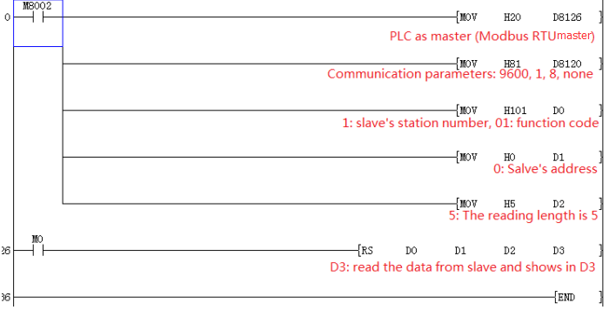

2. Read word address from device
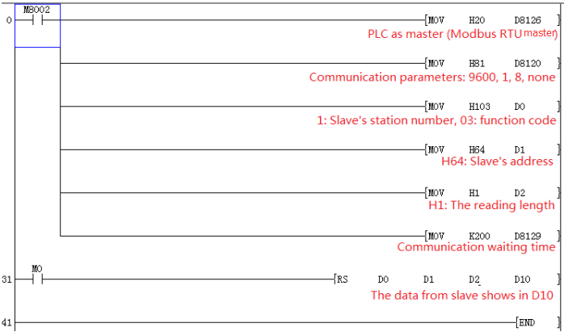

3. Write single coil
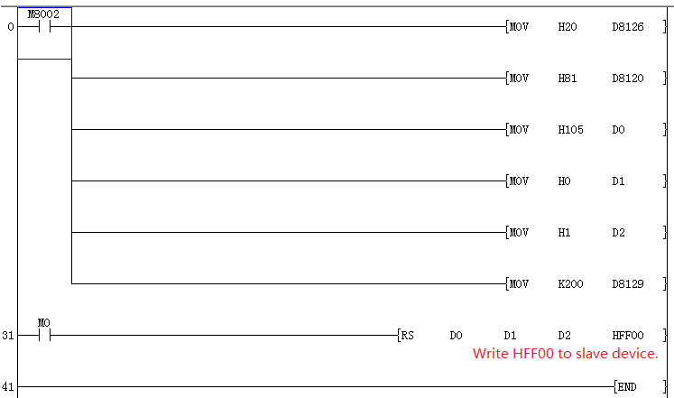
Tip:
(When writing a single coil or a continuous coil, write HFF00 to turn the coil on, and write H0000 to turn off the coil.)
4. Write single register
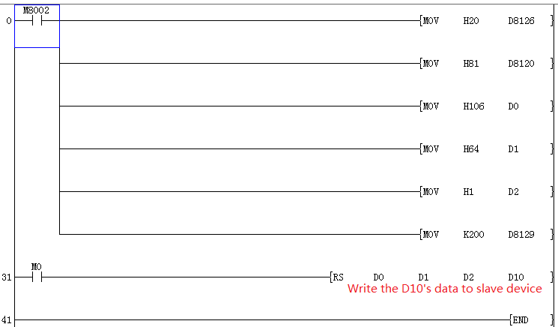

5. Write continuous coils
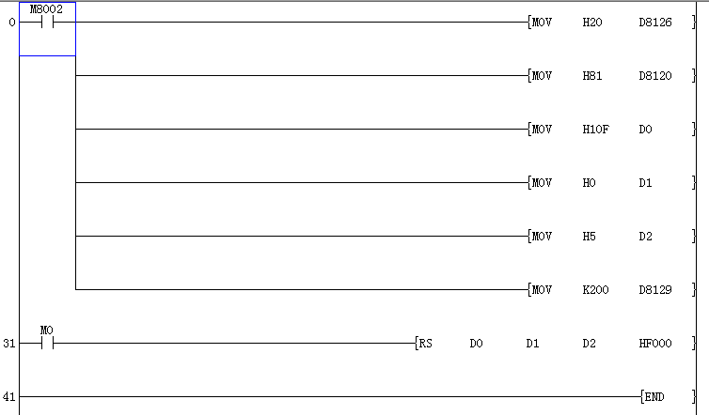

6. Write continuous registers
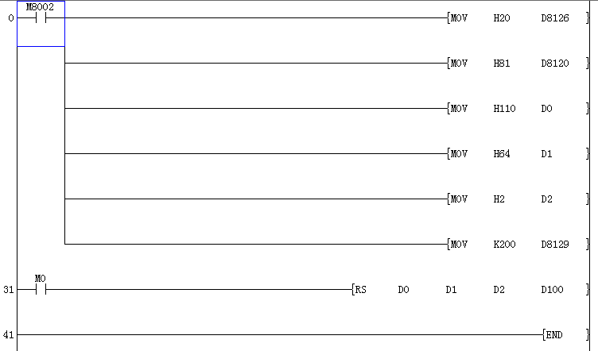

- PLC is slave devic
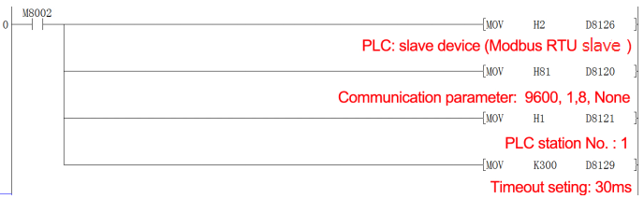

- WECON PLC Protocol (COM2)
